# Task Management Tool.

## Steps to follow to run the application

I have used Xampp for the Apache Api and the MySQL

**Step 1**: Open the Xampp and Start the Apache and the Mysql

**Step 2**: We need to import the task_allocation.sql file into the phpadmin.

**Step 3**: In the Command prompt go the TaskManagementTool folder location and execute the command "ng serve"

**Step 4**: In the Command prompt go the Server folder location and execute the command "node index.js"

**Step 5:** In the browser go to localhost:4200

## Functionality:

-->Once we give the credentials it will validate and takes us to the next page where we can see Create task/Create User for the Manager credentials and for the regular user it will navigate only Tasks List (i.e it will display the tasks assigned to user)

-->Manager can create a task and assigned to a specific user and he can also create a new user by giving the required details when creating a new use, the password is autogenerated and we can see the username and password in mysql.

### Login Page

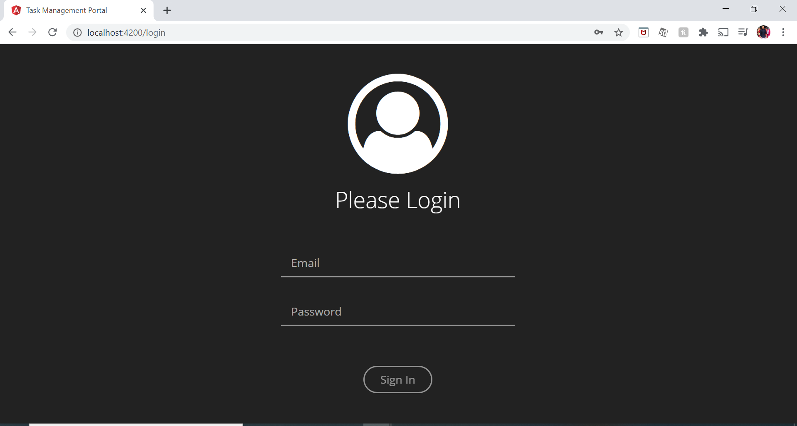

### Manger Create User

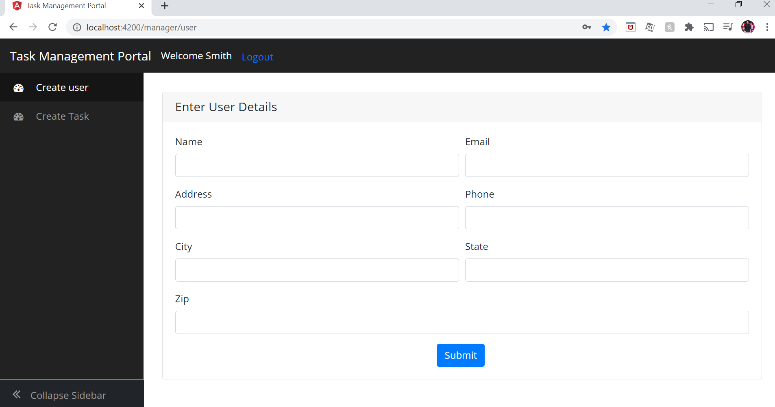

### Manager Create Task

### 

### Regular User

